Probability Unit

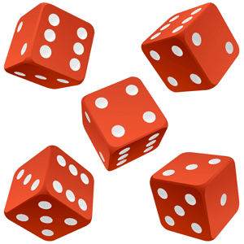

2nd Grade

Veronica Kleefeld, vkleefeld@clbs.k12.mn.us
Tila Basar, tbasar@clbs.k12.mn.us
Lindsi Shanahan, Lindsi_Shanahan@isd31.net

Math 6600

Executive Summary
This unit is designed to teach basic probability concepts through experimental probability activities (fair and not fair; impossible, possible and certain; and possible outcomes) along with graphing and data collection through a variety of games and activities.

The lessons are designed with some whole group instruction as well as small group centers. The centers are designed to be done 1 per day with students completing all 4 centers in 4 days. “At Your Seat” is designed to be a review or mini assessment of the concepts taught. “Hands On” is a small group activity related to the math concept. “Math Facts” is designated as a time to practice basic math facts and/or additional practice on the concept being taught with a partner or small group. “Teacher’s Choice” is a small group mini lesson to either introduce a new concept, or to reinforce and extend a previous topic.
This 15 day unit is aligned with NCTM Standards of Probability for K-2nd grade and MN State Standards for Mathematics. The specific standards include;

NCTM Standard for K-2nd Grade: Understand and apply basic concepts of probability

Minnesota State Math Standards
* 2.1.1.1 Read, write and represent whole numbers up to 1000. Representations may include numerals, addition, subtraction, multiplication, words, pictures, tally marks, number lines and manipulatives, such as bundles of sticks and base 10 blocks.
* 2.1.2.1 Use strategies to generate addition and subtraction facts including making tens, fact families, doubles plus or minus one, counting on, counting back, and commutative and associative properties. Use the relationship between addition and subtraction to generate basic facts.
* 2.1.2.2 Demonstrate fluency with basic addition facts and related subtraction facts.
* 2.1.2.6 Use addition and subtraction to create and obtain information from tables, bar graphs and tally charts.

Activities/games downloaded for free-
Clear-The-Board-
http://www.kidscount1234.com/mathcentersandgames.html
Table of Contents
Lesson Page
Day 1 What is Certain and Impossible? 4
Day 2 Introduce Probability 6
Day 3 Spinners and Predictions 8
Day 4 Teddy Graham Predictions 10
Day 5/6 Number Cubes and Predictions/Graphing 12
Day 7 Possible Outcomes 15
Day 8 Land or Water 16
Day 9 Probability of an Event 17
Day 10 Which bag is which? 18
Day 11 Color Prediction 19
Day 12-15 Centers 21
Pre/Post Test 7

Day 1: What is Certain and Impossible?
Objective: Students will investigate the likelihood that an event is either impossible or certain.
Materials: sentence strips with the following written: “I have a pet dinosaur" and “the teacher is older than every student in our class;” Certain and Impossible sort
Launch: Write the headings impossible and certain on the classroom whiteboard. Teacher will start by sharing two statements, “I have a pet dinosaur" and “the teacher is older than every student in our class.” As a class, decide if the statements are impossible or certain. Children will then be asked to help contribute to the lists. Questions to guide the children “Are there some things you are positive will happen?” “What can never happen?” Teacher will explain that events that will happen are called certain and events that cannot happen are called impossible.
Explore: Give the students the Certain and Impossible sort. They will work with a partner to sort the statements into two piles: Certain and Impossible. After the class has classified the statements, discuss with them the reasons for their classifications.
Share: To confirm their understanding of certain and impossible, ask the students to share examples of their everyday lives that would fit in the classified groups of certain and impossible.
Summarize: Is it possible for two children to have different answers and for both to be correct? As the children discuss, you will get an insight into their conceptions and misconceptions about early probability concepts.

Impossible | Certain
You will go to school. | You will eat food.
A talking horse will teach our class today. | A turtle will grow wings and fly.
You will sleep tonight. | It will be Sunday tomorrow.
You will have recess. | A monkey will knit you a blanket today.
The lakes will turn pink. | You will see a person.
You will get dressed | You will breathe.
You will drink something. | You will lay an egg.
We will never talk again. | You will buy a house today.
You will go to the bathroom. | An octopus will fly a helicopter.

Day 2 Introduce Probability Second Grade Math Expressions Unit 13

Pretest Page 462 in Student Workbook.

Materials: 2 paper bags (one for the first Explore and Share, one for the second Explore and Share activity.), 5 blue connecting cubes, 3 green connecting cubes

Objective: Describe events as impossible, possible, or certain.

Launch: “Today we are going to talk about the word Probability! Probability is used to describe how likely it is for something to happen.” Write the words Impossible, Possible and Certain on the board and tell children that they will use these words to describe different events. Vocabulary: Probability, Impossible, Possible, Certain

Explore and Share: Discuss the meaning of the three words and compare them to ordinary words or phrases, such as no way, maybe, for sure. Then ask volunteers to describe events that are impossible, possible, and certain.
Ask Students:
· Who can describe something that is impossible?
· Who can describe something that is possible?
· Who can describe something that is certain to happen?
Draw from a hat a few scenarios:
· Summer will follow spring. (certain)
· A giraffe will fly. (impossible)
· It will be sunny tomorrow. (possible)
Have children watch you place 5 blue connecting cubes in an empty paper bag. Then ask the following questions:
· What is the likelihood of picking a blue cube? (certain)
· What is the likelihood of picking a green cube? (impossible.
Now place 3 green cubes in the paper bag along with the blue cubes and ask the questions again.
· What is the likelihood of picking a blue cube? (possible)
· What is the likelihood of picking a green cube? (possible)

Summarize: Review new vocabulary words Probability, impossible, possible, and certain. For a quick assessment, have students write something that is impossible on a sticky note to turn in.

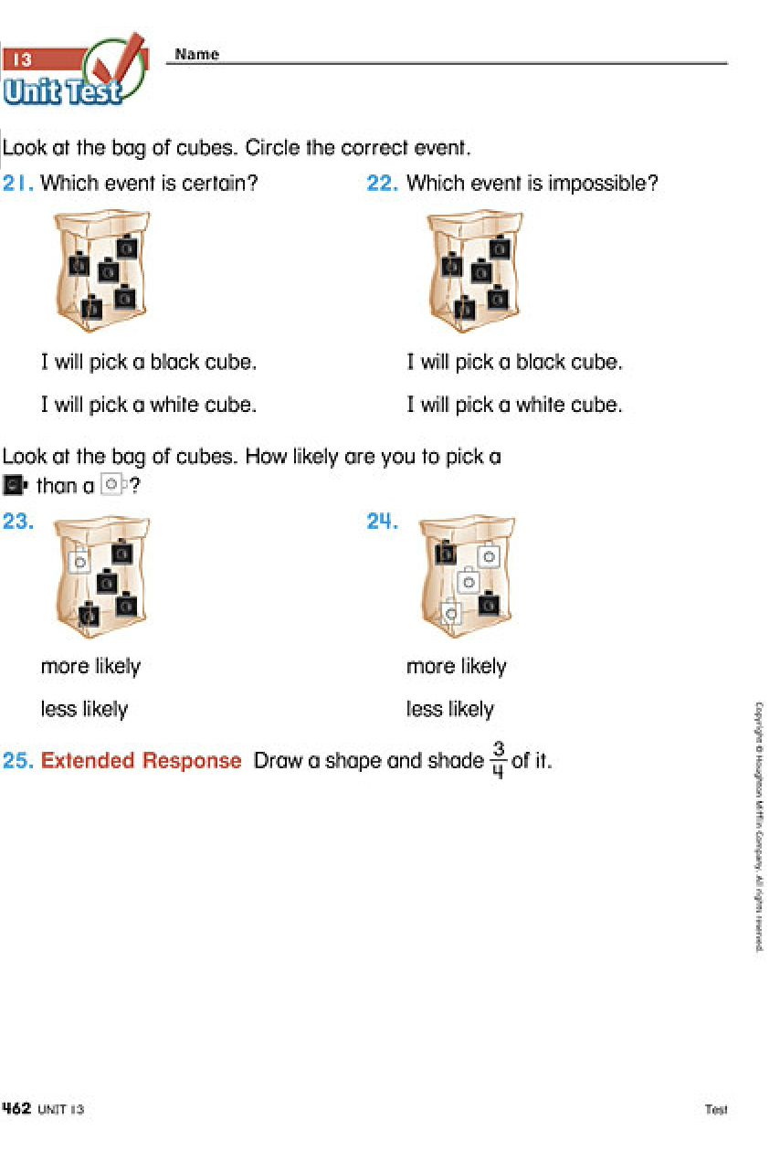
Day 3 Spinners and Predictions Second Grade Math Expressions Unit 13

Materials: Crayons or Colored Pencils (one red, one blue per child), Student Activity Book page 453, paper clips (one per pair)

Objective: Discuss whether a game is fair or unfair.

Launch: Review the word Probability and introduce vocabulary words fair and unfair. Have students come up with a few examples of situations that are fair or unfair.

Explore: Make a Game Spinner. Have students get in pairs and pull out page 453 from their Student Activity Book. Have them color the larger section of the spinner red and the smaller section of the spinner blue. Show children how to use a paper clip as a pointer and a pencil as a pivot.
Rules: Have pairs take turns spinning the paperclip 10 times each. One child gets a point if the spinner lands on red. The other child gets a point if the spinner lands on blue. Determine who gets a color by playing Rock, Paper, Scissors. Children record their points on a piece of paper.

Share: Circle up to discuss the game. Ask:
· If you were going to play the game again, which color would you rather have? Why?
· On which color is the spinner more likely to land? On which color is the spinner less likely to land?
· Do you think the game was fair or unfair?

Summarize: Ask students if they agree that the game was unfair. Talk about how it could be made fair.
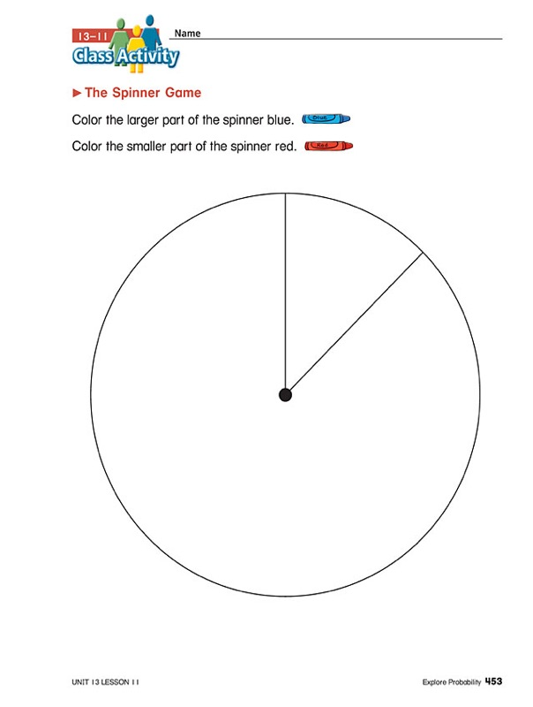

Day 4 Teddy Graham Predictions

MN State Standards: 2.1.1.1, 2.1.2.6

Objective: Students will predict, record, and analyze data into a bar graph.
Materials: Teddy Grahams, bar graph, pencil
Launch: Give each student a small cup of teddy grahams. Have the class examine their Teddy Grahams. Ask them what they notice about their teddy grahams. (Some have arms up and some have arms down.) Have the class predict how many Teddy Grahams are in the cup, how many have the arms up, and how many have the arms down. Show the children where to record their predictions on their page.

Explore: Students will sort their teddy grahams by arm direction. Then the students will represent their totals on a tally chart. Once the tally chart is complete, the students will transfer their tally data onto the graph.

Share: Students will share/compare their graphs with their table groups. Pick one student to share their graph under the document camera. Ask the students, “What does this graph show you?” “What do you notice about the column that has arms up? Arms down?” Pick a second student to share their graph. Ask the same previous questions and “Are these graphs the same?” “What is different?” Based on what you know about what is on the graphs. Can you predict what is likely to be in my cup? Discuss various predictions based on the different graphs. Why might I say “what is likely in my cup?” (our graphs were similar but not exactly the same).

Summarize: Have a class discussion about how many options there where when creating the graph and if any two graphs look exactly the same. While the children were working on their graph, the teacher could have gotten the totals of all the arms up and down from each student to share what the graph looks like for the entire class.
Name ________________________________________________

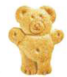 Teddy Grahams

I predict there are _____ Teddy Grahams in my cup.

I predict _____ Teddy Grahams have their arms up.

I predict _____ Teddy Grahams have their arms down.

* * * * * * * * * * * * * * * * * * * * * * * * * * * * * * * * * * * * * * * *

Tally how many Teddy Grahams have their arms up and down?

Teddy Grahams | Tally | Total
arms up
arms down

* * * * * * * Total number of Teddy Grahams ________ * * * * * * *

Teddy Grahams Graph
arms
up
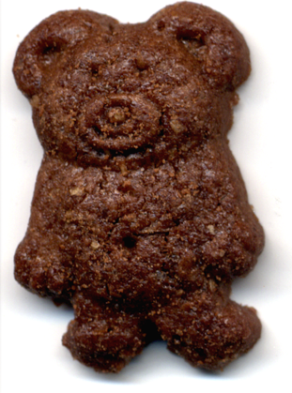 | arms  down
 |  | 1 | 2 | 3 | 4 | 5 | 6 | 7 | 8 | 9 | 10 | 11 | 12 | 13 | 14 | 15

Day 5 and 6 Number Cubes and Predictions Second Grade Math Expressions Unit 13
MN State Standards: 2.1.2.1, 2.1.2.2, 2.1.2.6

Materials: Number cubes (two per pair), Student Activity Book page 454

Objective: Predict the results of a probability experiment and then do the experiment to check the prediction. On day 5 we will graph the results.

Launch: Review the word Probability and discuss that making a prediction means you are making a guess. Tell children that we will be making a prediction, then playing a game to see if our prediction is right or close.

Explore: Probability Experiment-Tell children that they will roll two number cubes 30 times and keep track of the total each time with tally marks. Explain that the table on Student Activity Book page 454 shows all the possible totals.
Children will use the table to record their results as they do the probability experiment. Before they begin, have children predict whether a total of 2 or a total of 7 is more likely to be rolled. Tell them to write their prediction on the top of their paper. On day 5 students will graph their results.

Share: When they have finished the experiment, have children share their results.

Summarize: Which numbers have a total of 2? Which numbers have a total of 7? Why is a total of 7 more likely than a total of 2? Would you change your prediction if you had a chance to play again? For a short assessment, place different combinations of colored connecting cubes in a paper bag. Then ask the children to use the terms impossible, possible, and certain to describe the likelihood of choosing a particular color.

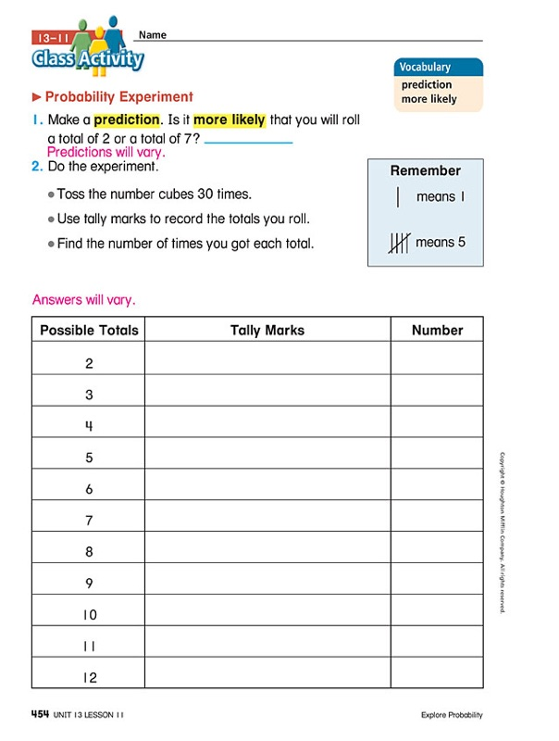

Day 7 Possible Outcomes Second Grade Math Expressions Unit 13

Materials: Small brown paper bag, connecting cubes (15 blue, 4 red, and 1 green), MathBoard materials

Objective: Identify all possible outcomes for a probability experiment and decide which is most likely and least likely to happen. Then do the experiment to check the prediction.

Launch: Ask children for ideas. Introduce the word “outcome”. Describe an outcome as the result of an experiment or as what “comes out”. Ask:
- If you toss a coin, what are the possible outcomes? (heads or tails)
- If you spin a spinner that is part green and part blue, what are the possible outcomes? (landing on a green or blue)
Tell children that they will conduct an experiment as a class where they pick a cube from a bag without looking. Have children watch you fill a paper bag with 15 blue cubes, 4 red cubes, and 1 green cube. Then discuss the possible outcomes with the children.
- What are the possible outcomes for this experiment? (choosing a blue, red, or green cube.)
- What outcome do you think is most likely? (choosing a blue cube) Why? (There are a lot more blue cubes in the bag than there are any other color.)
- What outcome do you think is least likely? (choosing a green cube) Why? (There is only one green cube in the bag.)

Explore: Write children’s predictions for the most likely and least likely outcomes on the board. Tell them that they will now do the experiment to test their predictions. Draw a chart and have a student leader use it to record the results of the experiment.

Have the other children come to the front of the room one at a time to pick a connecting cube from the bag and have the student leader record the color that is picked each time. Be sure the cube is placed back into the bag after each turn.

Repeat this process until about 40 cubes have been picked from the bag. Then have the class count the tally marks to find the total number of each color that was picked.

Sharing: Have the children circle up to discuss how the results compare to their predictions. Talk about how their predictions were different or the same as in the experiment.

Summary: Children should have identified all possible outcomes and decided which is most likely or least likely to happen.

Day 8 Land or Water

MN State Standards: 2.1.1.1, 2.1.2.6

Objective: Students will perform an experiment to determine if the world has more water or land through the use of tally marks and counting.

Materials: Inflatable globe; Land Water slip; pencil

Launch: Show the class an inflatable globe. “What is this called?” “What does it show?” “Why do we use them?” Have the class make a prediction if there is more land or water on the globe. Record the results on the whiteboard. Model how to toss the globe and that their right thumb marks the spot to look at. Toss the ball to a student ask them “land or water,” tally their response. Continue to toss the ball and tally the result, 4 more times.

Explore: Students will be given a Land Water slip. Have the students make their own prediction (is there more land or water?) by circling land or water. Students will then be placed into four groups. The groups will take turns tossing the globe and tallying whether the thumb landed on land or water. Continue to play Land or Water until each group has at least 20 tally marks. The groups will then count how many tally marks for land and water.

Share: Combine all of the group numbers together on one large tally chart. Have a discussion about what students are noticing as all of the data is being combined.

Summarize: Have a class discussion about what the data shows. Did their prediction align with the data? How did the group data compare with the combined class data?

Land | Water
Total number of land: ________ Total number of water: ________
Day 9 Probability of an Event Second Grade Math Expressions Unit 13

Materials: Teacher bag, enough bags for students to have in groups of 4, Blue, Red, and Green cubes, enough for teacher example and student activity.

Objective: Use numbers to describe the probability of an event.

Launch: Tell the children that in the activity they will be using numbers to describe the chance of something happening. Show the children six connecting cubes: 3 blue, 2 red, and 1 green. Tell them that you are setting up a probability game and you want them to help you figure out the probability of picking each color from the bag.
- How many cubes will be in the bag? (6 cubes)
- How many of the cubes are blue? (3 cubes)
Write 3 out of 6 on the board and explain that 3 out of 6 means that there are 3 out of 6 chances of picking a blue cube.
- How many cubes are red? (2 cubes)
- How could we use numbers to write the probability of picking a red cube? (2 out of 6)
- How many are green? (1 cube)
- How could we use numbers to write the probability of picking a green cube? (1 out of 6)

Explore: Empty out the bag and tell children that this time you want to fill the bag with 4 blue cubes, 2 red cubes, 3 green cubes, and 1 yellow cube. Have children work in groups of 4 to identify the probability of picking each of the colors.
- How many cubes will be in the bag this time? (10 cubes)
- How many of the cubes are blue? (4 cubes)
- How could we write the probability of picking a blue cube? (4 out of 10)
- How many of the cubes are red? (2 cubes)
- How could we write the probability of picking a red cube? (2 out of 10)
Repeat the questions for green (3 cubes, 3 out of 10) and yellow (1 cube, 1 out of 10)
Have the children take turns picking a cube from the bag and tallying how many blue, red, green, and yellow (10 turns).

Share: Circle up to compare their probability answers with their experiment answers.

Summary: Students should be able to understand that their probability answers do not always line up perfectly with the experiment, but it should be close.

Day 10: Which bag is which? NCTM Navigating through Data Analysis and Probability
MN State Standards: 2.1.1.1, 2.1.2.6

Objective: Students will be able to tally which color of cubes are pulled from a bag. With the information the students have tallied, they will be able to predict which color there is more of in a given bag.

Materials: Three brown paper bags, each bag will contain 10 colored cubes (Bag 1: eight yellow cubes and two blue cubes. Bag 2: five yellow cubes and five blue cubes. Bag 3: two yellow cubes and eight blue cubes); Enough brown paper bags, for each pair of students (labeled "Bag A" with five red and five green); student whiteboard and marker.
Launch: Class will sit in a circle. Teacher will begin with paper “Bag 1”. Remove one cube from the bag, record its color on a chart. Teacher will ask: "What color is in the bag?" "Could there be other colors in the bag?" "How sure are you?" "Can you tell how many cubes are in the bag without looking in?" Replace the cube in the bag one.

Three more times, repeat the process above and ask: “What colors are in the bag?" "Which color do you think the next cube is more likely to be, blue or yellow? Why do you think that?" "Do you think there are more yellow cubes or blue cubes in the bag? Why do you think that?"
Repeat the same exercise with “Bag 2” and “Bag 3”. Then ask the students: "if you wanted to draw a yellow cube, which bag would you draw from? Discuss why they picked that bag. Have a student draw a single cube from that designated bag. Show the contents of all three bags. Discuss why the students are more likely to draw a yellow cube from bag one than from bag three.
Explore: Students will work in pairs. Each pair should have a student whiteboard, marker, and a paper bag marked "Bag A." Students will take turns pulling out one cube, making a tally mark for its color, returning it to the bag, choosing another cube, tally it's color, returning it to the big, and so on until 10 cubes have been chosen.
Share: The students share their results with the class. Discuss how many red and green they think are in "Bag A."

Summarize: After the students share, have the students count how many red and green are in "Bag A." Did the cube colors match the amount of tally marks they made?

Day 11: Color Prediction

MN State Standards: 2.1.1.1, 2.1.2.6

Objective: Students will be able to place cubes into a bag and try to make the outcome either much more likely, a bit more likely, or equally likely.
Materials: ten red cubes and ten green cubes for each pair of students; small paper bags; pre-cutted Color Prediction Slips; student whiteboards & markers
Launch: Teacher will review impossible, possible, or certain. Today, the children will play Color Prediction. To start, the teacher will need a paper bag, ten red cubes, ten green cubes, and one of the Color Prediction Slips (for example: RED IS MUCH MORE LIKELY). Have a class discussion on how many reds and greens to put into the bag, there can only be ten cubes in the bag. Once the ten cubes have been chosen, model how to pull one cube out, tally the color, and then return the cube back to the bag. Continue to model how to pull, tally, and return the cubes until ten tally marks have been made. After the tenth tally marks, have a class discussion: “What worked well” or “What did not go well?” “What could be done differently?”

Explore: Students will work in pairs. Each pair should have a paper bag, ten red cubes, ten green cubes, and one color prediction slip. The students will then fill their bags with some red and green cubes, so that their color prediction slip is likely to be true. After they have filled their bag, the students need to complete the experiment by taking turns choosing one cube at a time, tallying the color on their student whiteboards, and then returning the cube back to the bag until ten cubes have been chosen.
Share: Have the students share their results and talk about why it might be possible to put different numbers of red cubes in a bag and get similar results.

Summarize: After working with a partner, ask the students: “What worked well?” “What did not work?” “What could be done differently?”

Color Prediction Slips
Red is much more likely. | Red is a bit more likely.
Green is much more likely. | Green is a bit more likely.
Red and green are equally likely. | Red is much more likely.
Green is much more likely. | Red is a bit more likely.
Red and green are equally likely. | Green is a bit more likely.
Red is much more likely. | Red is a bit more likely.
Green is much more likely. | Green is a bit more likely.
Red and green are equally likely. | Red is much more likely.
Green is much more likely. | Red is a bit more likely.
Red and green are equally likely. | Green is a bit more likely.
Red is much more likely. | Red is a bit more likely.
Green is much more likely. | Green is a bit more likely.
Red and green are equally likely. | Red is much more likely.
Green is much more likely. | Red is a bit more likely.
Red and green are equally likely. | Green is a bit more likely.
Day 12-15 Centers

MN State Standards- 2.1.2.1, 2.1.2.2, 2.1.2.6

Launch: For the past couple of weeks we have been talking about probability and how likely something can or will occur. The next four days you will be using that knowledge to complete your centers.

Explore: Rotate through 1 center each day.

Math Facts- Clear The Board
Place the “Dice Facts” graph that was previously created in the center area to remind students of which sums are rolled the most and which are rolled the least. Students place 10 markers anywhere on the board they want. They then take turns rolling 2 dice and adding the numbers together. If there is a marker on that number the student removes one. If there is no marker to remove the next player takes their turn. Whoever clears their board first wins.

At Your Seat- Impossible, Certain, or Equally Likely Sort
As a group read the sentence cards and decide if it is “Impossible”, “Certain”, or “Equally Likely”. Sort them under the correct heading.

Teacher’s Choice- (Adapted from Investigation 1 Session 7, Between Never and Always, Dale Seymore Publications)
Launch- Today we are going to play “IT’S YOUR CHOICE!” before we start playing you get to choose how you will score your points from the 5 different options because “IT’S YOUR CHOICE!”

Explore- Players decide how they want to score points by choosing 2 options from the 5 listed on the game board before play starts. Once everyone has made their selections the game begins. To play spin the spinner and determine who scores points.

Share- What strategy did you use when deciding which 2 options to score points from?

Summarize- Some of you noticed that some spaces on the spinner gave you better chances of winning. You were more likely to spin certain options and some spins worked for more than one option.

Hands On- Fair and Unfair Games
The Smart Games game factory has asked us to test out a few new games of theirs. They want us to tell them what we think of them and make suggestions for improvement. When you are done playing the games complete the question page but do not tell anyone about the games so they can make their own decisions about each game.

Share and Summarize:
After Day 15 share and summarize the results of each center as a whole group.

Math Facts-
Is there any strategy as to where you place your markers before the game begins. Refer back to the graph of how many times a number is rolled and how you might want to put more of your markers in the middle of the board to have a better chance of rolling that sum.

At Your Seat-
What were some of the sentences you put under “Impossible”? “Likely”? “Equally Likely”? Why? Is there a chance some groups sorted them differently? (Ex. If someone does not like bananas they would put it under “Impossible” vs. someone who knows they have a banana in their lunch.)

Teacher’s Choice-
Share any other observations made during the small group time with the whole group.

Hands on-
What were your thoughts about the game 1? What were your thoughts about game 2? Were they possible or impossible to win? What would need to change to make them possible? Sometimes we will look at a game and think it looks good, but then if you look harder you will see there are parts that just are not fair, like all the orange spaces on the spinner game when there is no orange on the board, and purple is not on the spinner but you need to have it to win the game. Also, rolling the numbers on the dice rolling game are not even possible in the middle of the board so you can not get past them to win.

SMART GAMES
Names ___________________
___________________
___________________
___________________
Game prototype 1
How many times did you play? ____________________________
Who won? ____________________________________________
What did you like? _____________________________________
_____________________________________________________
What did you not like? __________________________________
_____________________________________________________

Game prototype 2
How many times did you play? ____________________________
Who won? ____________________________________________
What did you like? _____________________________________
_____________________________________________________
What did you not like? __________________________________
_____________________________________________________
Impossible  (Will NOT happen) | Certain (WILL happen) | Equally Likely (Maybe)
It will snow in July at school. | We will go to lunch on Friday. | A fisherman will catch a fish.
I will walk in outer space this week. | The sun will come out tomorrow. | My pencil will need to be sharpened this week.
I will sleep for 8 hours tonight. | We will have recess outside. | A dog will say her name.

I will eat a banana today at lunch. | We will run outside today. | I will read with my friends.
We will give everyone $100 this week. | We will say The Pledge tomorrow morning. | The walls will be covered in slime tomorrow.
There will be pears at lunch today. | We will all take a field trip to Florida. | We will read from a book tomorrow.

